Health Enhancing or Health Risking?
During this section of CALM we will be looking at the dimension that we have the most control over. That is the Physical Dimension of our health. Several of the day to day choices that we make regarding what we eat, what we do in our spare time, and what we perceive as stressful or not stressful affect our well-being. They either can enhance our health or put our health at risk.
Today, lifestyle-related disease such as heart disease, strokes, and cancer are leading causes of death. The other leading cause of death is car collisions-many of which are drug and alcohol related.

- Eating Healthy
Healthy eating nourishes the body, including the brain, and supports mental health through:
• Improved overall health and vitality
• Increased ability to concentrate
•Reduced irritability and mood swings
• Lowered risk of tiredness and illness
There is some evidence that healthy eating may be a factor in lowered risk of depression and improved ability to deal with stress and anxiety.
One of the major tools used in Canada to help citizens decide what is and isn’t healthy to eat is the Canadian Food Guide. The other tool which is mandated by Health Canada is that every product needs to have a food label identifying ingredients, and a nutrition fact table.
Label Reading 101 - https://www.youtube.com/watch?v=MrdCBqFYDyo
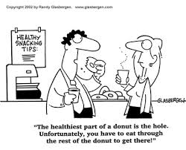

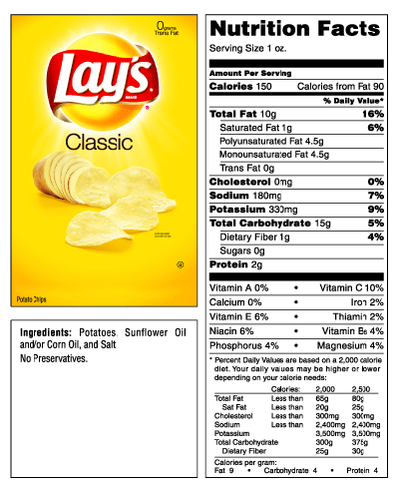
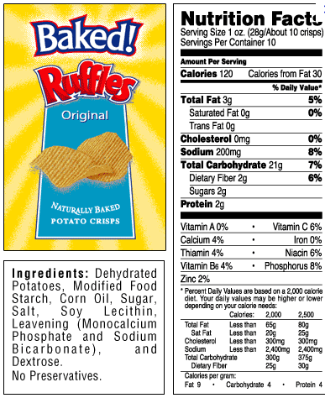
After watching the following clip on reading food labels, decide which of the following food items is healthier and explain why.

Supersize me in 7 minutes https://www.youtube.com/watch?v=N2diPZOtty0
After watching “Supersize Me in 7 Minutes” click on the following PADLET link below and in 4 sentences starting with your name, answer the question:
Here is the padlet link to write on: http://padlet.com/BergenA/6bo9hmgzdhnn
Is “SuperSize Me” an example of “health enhancing” or “health risking.” In two sentences explain your reaction to this video.

- Active Living
There is extensive research to suggest that living an active lifestyle results in a healthy heart, lungs, and body- longer life. Canada’s Physical Activity Guide to healthy living recommends that 13-18 year old individuals should spend:
- 60 minutes of the day on light effort activities- like walking
- 30-60 minutes per day on moderate effort activities – like running or riding a bike
- 20-30 minutes per day on vigorous effort activities – like playing football, basketball or soccer
Canada’s Physical Activity Guide. Click on the link to see the Canadian Activity Guidelines.
http://www.csep.ca/CMFIles/Guidelines/CSEP_PAGuidelines_adults_en.pdf
Being Active for at least 150 minutes per week can help reduce the risk of:
1.
2.
3.
4.
5.
6.
7.
8.

Is there such thing as Exercising too much???
Watch the following links about Exercise Addiction and respond to the questions below.
Intense Facts about Exercise Addiction –
https://screen.yahoo.com/intense-facts-exercise-addiction-225251474.html
Exercise Addiction-
https://www.youtube.com/watch?v=ne4pJ9QZQMM
After watching these two video clips in the Padlet Link below starting with your name, answer the following questions:
Padlet Link http://padlet.com/BergenA/a0w3sm2z561z
- At what point is exercise considered an addiction.
- What are the signs that someone is addicted to exercise.

